Assignment 1

Due date : 3/18/2022

Lee Jeong-Yun 21102052

1. For the Ex 1-13 on p24, answer to the following questions by using R.

a) Use class intervals 10-<20, 20-<30, $⋯$ to construct a histogram of the original data (IDT).

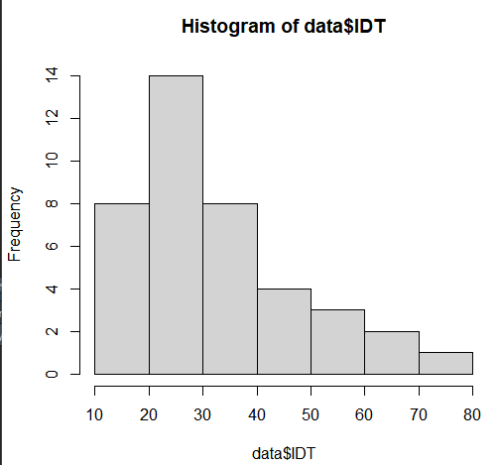

b) Use intervals 1.1-<1.2, 1.2-<1.3, $⋯$ to do the same for the transformed data. $\log_{01}(IDT)$

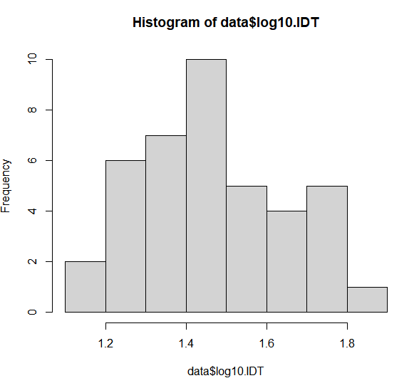

c) Draw the stem and leaf graph for log10.IDT variable

d) Draw the box plot for IDT variable.

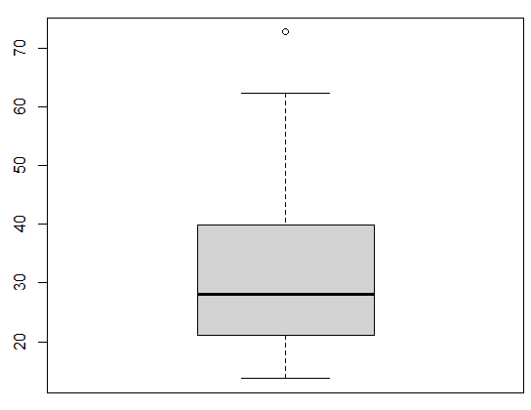

The data can be accessed by the following commands.

* install.packages("Devore7")
* Library(Devore7)
* data <- ex01.25;data
* R codes to solve the problems.

install.packages("Devore7")

library(Devore7)

data1 <- ex01.25;data

hist(data1$IDT)

hist(data1$log10.IDT, breaks = seq(1.1,1.9,by=0.1))

stem(data1$log10.IDT)

boxplot(data1$IDT)

2. (Ex 1-45 on page 43) The article “A Thin-Film Oxygen Uptake Test for the Evaluation of Automotive Crankcase Lubricants” (Lubric. Engr., 1984: 75–83) reported the following data on oxidation-induction time (min) for various commercial oils:

87 103 130 160 180 195 132 145 211 105 145 153 152 138 87 99 93 119 129

a) Calculate the sample mean, sample variance, sample standard deviation and sample median.

**Sample mean = 134.9**

**Sample variance = 1264.766**

**Sample standard deviation = 35.56355**

**Sample median = 132.0**

b) If the observations were reexpressed in hours, what would be the resulting values of the sample variance and sample standard deviation? Answer without actually performing the reexpression.

**Var(aX+b) = a^2Var(X)**

**sd(aX+b) = |a|*sd(X)**

**In this case, X*1/60 = Y. Var(Y) = (1/60)^2*Var(X) and sd(Y) = (1/60)*sd(X)**

**As a result, the sample variance of re-expressed data is 0.3513239,**

**and sample standard deviation of re-expressed data is 0.5927258.**

The data can be accessed by the following commands.

* Library(Devore7)
* data <- ex01.51;data
* R codes to solve the problems

library(Devore7)

data <- ex01.51;data

summary(data$C1)

var(data$C1)

sd(data$C1)

3. (Slightly modified version of Ex 2-13 on p. 62) A computer consulting firm presently has bids out on three projects. Let $A_{i}=\{awarded project i\}$, for $i=1, 2, 3$, and suppose that $P\left(A_{1}\right)=0.2$, $P(A_{2} )=0.25$, $P\left(A_{3}\right)=0.25$, $P\left(A_{1}∩A_{2}\right)=0.11$, $P\left(A_{1}∩A_{3}\right)=0.05$, $P\left(A_{2}∩A_{3}\right)=0.07, P\left(A_{1}∩A_{2}∩A_{3}\right)=0.01$. Compute the probability of the following events.

**a = 0.2+0.25-0.11= 0.34, cf) A1+A2-(A1 $∩$ A2)**

**b = 1-0.34 = 0.66, cf) 0.34=a, 1-(A1 U A2)**

**c = 0.2+0.25+0.25-0.11-0.05-0.07+0.01 = 0.48,**

**cf) A1+A2+A3-(A1 $∩$ A2)-(A1 $∩$ A3)-(A2 $∩$ A3)+(A1 $∩$ A2 $∩$ A3)**

**d = 1-0.48=0.52 cf) 0.48=c, cf) 1-(A1 U A2 U A3)**

**e = 1-0.2-0.25+0.11 = 0.66, cf) 1-A1-A2+(A1 $∩$ A2)**

**f = 1-0.34+0.05+0.07-0.01 = 0.77,**

**cf) 1-(A1 U A2)+(A1 $∩$ A3)+(A2 $∩$ A3)-(A1 $∩$ A2 $∩$ A3)**

Using Venn diagrams and set operation formulas.

4. (Slightly modified version of Ex 2-59 on p82) At a certain gas station, 45% of the customers use regular gas ($A_{1}$), 35% use plus gas ($A_{2}$), and 20% use premium ($A_{3}$). Of those customers using regular gas, only 30% fill their tanks (event B). Of those customers using plus, 60% fill their tanks, whereas of those using premium, 40% fill their tanks.

|  |  |  |  |  |
| --- | --- | --- | --- | --- |
|  | Regular(A1) | Plus(A2) | Premium(A3) | SUM |
| B(fill) | 0.135 (=0.45*0.3) | **0.21 (=0.35*0.6)** | 0.08 (=0.2*0.4) | **0.425** |
| ~BI(not fill) | 0.315 (=0.45*0.7) | 0.14 (=0.35*0.4) | 0.12 (=0.2*0.6) | 0.575 |
|  | 0.45 | 0.35 | 0.20 | 1 |

a. What is the probability that the next customer will request plus gas and fill the tank ($A_{2}∩B$)?

**0.35*0.6 = 0.21**

b. What is the probability that the next customer fills the tank?

**0.425**

c. If the next customer fills the tank, what is the probability that regular gas is requested? Plus? Premium?

**Regular = 0.135/0.425 = 0.3176471**

**Plus = 0.21/0.425 = 0.4941176**

**Premium = 0.08/0.425 = 0.1882353**

5. (Ex 2-62 on p82) A company that manufactures video cameras produces a basic model and a deluxe model. Over the past year, 40% of the cameras sold have been of the basic model. Of those buying the basic model, 30% purchase an extended warranty, whereas 50% of all deluxe purchasers do so. If you learn that a randomly selected purchaser has an extended warranty, how likely is it that he or she has a basic model?

|  |  |  |  |
| --- | --- | --- | --- |
|  | Basic model | Deluxe Model | Sum |
| Warranty | 0.12 (=0.40*0.30) | 0.30 (=0.60*0.50) | 0.42 |
| No Warranty | 0.28 (=0.40*(1-0.30)) | 0.30 (=0.60*0.50) | 0.58 |
| Sum | 0.40 | 0.60 | 1.00 |

**Answer = 0.12/0.42 = 0.28571429**

6. (Ex 2-80 on p87) Consider the system of components connected as in the accompanying picture. Components 1 and 2 are connected in parallel, so that subsystem works iff either 1 or 2 works; since 3 and 4 are connected in series, that subsystem works iff both 3 and 4 work. If components work independently of one another and P(component works)=0.9, calculate P(system works).

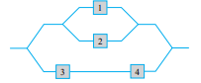

**Both subsystems from (1 or 2) and (3&4) work -> system works**

**1&~2&(3,4) = 0.9*0.1*(0.9)^2 = 0.0729**

**1&2&(3,4) = 0.9*0.9*(0.9)^2 = 0.6561**

**~1&2&(3,4) = 0.1*0.9*(0.9)^2 = 0.0729**

**P(system works) = 0.0729+0.6561+0.0729 = 0.8019**

**# “~” means “not”**

7. (Slightly modified version of Ex 2-101 on p90) A system consists of two components. The probability that the second component functions in a satisfactory manner during its design life is 0.8, the probability that at least one of the two components does so is 0.96, and the probability that both components do so is 0.65. Given that the first component functions in a satisfactory manner throughout its design life, what is the probability that the second one does also?

**Component 1 = A, Component 2 = B**

**P(B) = 0.8**

**P(A U B) = 0.96**

**P(A $∩$ B) = 0.65**

**P(A) = P(A U B) – P(B) + P(A $∩$ B) = 0.81**

**P(B | A) = Answer = P(A $∩$ B)/P(A) = 0.65/0.81 = 0.8024691**

Assignment 2

Due date : 4/8/2022

1. (Slightly modified version of Ex 3-32 on page 113) An appliance dealer sells three different models of upright freezers having 13.2, 15.9, and 19.1 cubic feet of storage space, respectively. Let X = the amount of storage space purchased by the next customer to buy a freezer. Suppose that X has pmf.

|  |  |
| --- | --- |
| x | 13.2 15.9 19.1 |
| p(x) | 0.3 0.45 0.25 |

Compute E(X), E(X2), and V(X).

E(X) = 13.2*0.3+ 15.9*0.45 + 19.1*0.25 = 15.89

E(X^2) = (13.2^2)*0.3+ (15.9^2)*0.45 + (19.1^2)*0.25

V(X) = E(X^2)-E(X)^2 = 4.7469

If the price of a freezer having capacity X cubic feet is 25X - 8.5, what is the expected price paid by the next customer to buy a freezer?

E(25X-8.5) = 25*E(X)-8.5 = 25*15.89-8.5 = 388.75

What is the variance of the price 25X - 8.5 paid by the next customer?

V(25X-8.5) = 25^2*V(X) = 160774.375

Suppose that although the rated capacity of a freezer is X, the actual capacity is

h(X) = X – 0.01 X2. What is the expected actual capacity of the freezer purchased by the next customer?

|  |  |  |  |
| --- | --- | --- | --- |
| X | 13.2 | 15.9 | 19.1 |
| X(1-0.01X) | 11.4576 | 13.3719 | 15.4519 |
| p | 0.3 | 0.45 | 0.25 |
| X(1-0.01X)*P | 3.43728 | 6.017355 | 3.862975 |
|  |  |  |  |
| E(X(1-0.01X)) | 13.31761 |  |  |

2. (Slightly modified version of Ex 2-66 on page 122) An airport limousine can accommodate up to four passengers on any one trip. The company will accept a maximum of six reservations for a trip, and a passenger must have a reservation. From previous records, 25% of all those making reservations do not appear for the trip. Answer the following questions, assuming independence wherever appropriate.

a. If six reservations are made, what is the probability that at least one individual with a reservation cannot be accommodated on the trip?

1-6C6*(0.75)^6*(0.25)^0 = 0.822021484

b. If six reservations are made, what is the expected number of available places when the limousine departs?

6*0.822021484 = 4.93212891

c. Suppose the probability distribution of the number of reservations made is given in the accompanying table.

|  |  |
| --- | --- |
| Number of observations | 3 4 5 6 |
| Probability | 0.1 0.2 0.3 0.4 |

Let X denote the number of passengers on a randomly selected trip. Obtain the probability that X=4 (P(X=4).

|  |  |  |
| --- | --- | --- |
|  | appear | disapear |
| 1 person | 0.75 | 0.25 |
|  |  |  |
| avg observation | 5 |  |
| 4 people 5 observation | 0.003171212 |  |

= (0.75^4)^5

3. (Slightly modified version of Ex 3-84 on page 132) Suppose that only 0.10% of all computers of a certain type experience CPU failure during the warranty period. Consider a sample of 10,000 computers.

What are the expected value and standard deviation of the number of computers in the sample that have the defect?

expected value = 0.001 * 10000 = 10

standard deviation = (0.001 * 10000 * 0.999)^(1/2) = 3.160696

What is the (approximate) probability that more than 10 sampled computers have the defect?

X = number of failure

P(X>10) = 1- P(X<=10)= 1- 0.5829946 = 0.4170054

*R codes for answer

a0 = (10000,0) * (0.999)^(10000-0) * (0.001)^0

a1 = choose(10000,1) * (0.999)^(10000-1) * (0.001)^1

a2 = choose(10000,2) * (0.999)^(10000-2) * (0.001)^2

a3 = choose(10000,3) * (0.999)^(10000-3) * (0.001)^3

a4 = choose(10000,4) * (0.999)^(10000-4) * (0.001)^4

a5 = choose(10000,5) * (0.999)^(10000-5) * (0.001)^5

a6 = choose(10000,6) * (0.999)^(10000-6) * (0.001)^6

a7 = choose(10000,7) * (0.999)^(10000-7) * (0.001)^7

a8 = choose(10000,8) * (0.999)^(10000-8) * (0.001)^8

a9 = choose(10000,9) * (0.999)^(10000-9) * (0.001)^9

a10 = choose(10000,10) * (0.999)^(10000-10) * (0.001)^10

a = a1+a2+a3+a4+a5+a6+a7+a8+a9+a10

print(1-a)

What is the (approximate) probability that no sampled computers have the defect?

0.999^10000 = 0.00452%

4. (Slightly modified version of Ex 3-93 on page 133) Suppose small aircraft arrive at a certain airport according to a Poisson process with rate $λ=7$ per hour, so that the number of arrivals during a time period of t hours is a Poisson rv with parameter $λ=7t$.

a. What is the probability that exactly 6 small aircraft arrive during a 1-hour period? At least 6? At least 10?

dpois(x = 6, lambda = 7) = 0.1490028

1 - ppois(q = 5, lambda = 7, lower.tail = TRUE) = 0.6992917

1 - ppois(q = 9, lambda = 7, lower.tail = TRUE) = 0.1695041

b. What are the expected value and standard deviation of the number of small aircraft that arrive during a 90-min period?

$$λ=7t=7*1.5=10.5$$

Expected value = $λ=10.5$

Standard deviation = $\sqrt{λ}= 3.24037$

c. What is the probability that at least 20 small aircraft arrive during a 2.5-hour period? That at most 10 arrive during this period?

$$λ=7t=7*2.5=17.5$$

1-sum(dpois(x=c(0:20), lambda = 17.5)) = 0.2305656

sum(dpois(x=c(0:10),lambda = 17.5)) = 0.03874505

5. (Slightly modified version of Ex 4-22 on page 151) The weekly demand for propane gas (in 1000s of gallons) from a particular facility is an rv X with pdf

$f\left(x\right)=\left\{\begin{matrix}2\left(1-\frac{1}{x^{2}}\right) & 1≤x≤2 \\ 0 & otherwise\end{matrix}\right.$

Calculate $P\left(X≤1.5\right)$

F(1.5)-F(1) = 0.333333

Calculate $P\left(1.5≤X≤1.8\right)$

F(1.8)-F(1.5) = 0.377778

Obtain the cumulative distribution function.

F(x) =

0 (x<1)

2x+2x^(-1)-4 (1=<x<=2)

1(x>2)

Calculate the median of X.

median -> 50% percentile

about 1.640672

Calculate the $E\left(X\right)$

$$\int{xf(x)}dx$$

3-2ln2

Calculate the $E\left(X^{2}\right)$

$$\int{x^{2}f(x)dx}$$

about 2.666667 = 8/3

Calculate $V\left(X\right)$

$$\int{x^{2}f(x)dx}-{(\int{xf(x)}dx)}^{2}$$

about 0.0626208

If 1.5 thousand gallons are in stock at the beginning of the week and no new supply is due in during the week, how much of the 1.5 thousand gallons is expected to be left at the end of the week? [Hint: Let h(x) = amount left when demand = x.]

h(x) = 1.5 – f(x)

= 3(1-x^(-2)) (1<=x<=2)

= 0 (otherwise)

expected left gas = = 1.5

6. (Slightly modified version of Ex 4-27 on page 152) Example 4.5 introduced the concept of time headway in traffic flow and proposed a particular distribution for X = the headway between two randomly selected consecutive cars (sec). Suppose that in a different traffic environment, the distribution of time headway has the form

$f\left(x\right)=\left\{\begin{matrix}\frac{k}{x^{4}} & x>1 \\ 0 & x≤1\end{matrix}\right.$

Determine the value of k for which f(x) is a legitimate pdf.

$$\int{f(x)}dx=1$$

k/3= 1, k=1

Obtain the cumulative distribution function.

F(x) = -x^(-3)+1 (x>1) or 0 (x<=1)

Use the cdf from (b) to determine the probability that headway exceeds 2 sec and also the probability that headway is between 2 and 3 sec.

1- F(2) = 0.125

F(3)-F(2) = 0.087963

Obtain the mean value of headway and the standard deviation of headway.

$\int{xf(x)}dx$ = 1.5

$\int{x^{2}f(x)dx}-{\left(\int{xf\left(x\right)}dx\right)}^{2}=3-{1.5}^{2}=0.75$ = V(x)

$\sqrt{0.75}=standard deviation=$ 0.8660254

What is the probability that headway is within 1 standard deviation of the mean value?

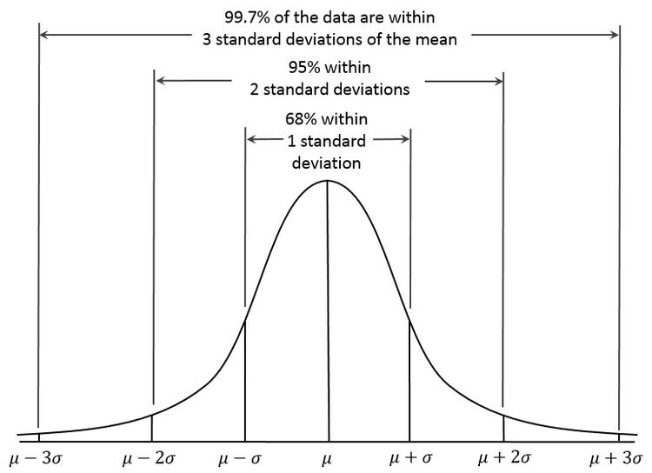

around 68%